

The yield curve and QE

Speech given by Gertjan Vlieghe External MPC Member Bank of England

Imperial College Business School Tuesday 25 September 2018

I would like to thank Rodrigo Guimarães, Yad Selvakumar, Manveer Sokhi, Ali Schomberg, Mike Joyce, Michael Saunders, Silvana Tenreyro, Michael McLeay, Clare Macallan for help with data and comments.

There is a great deal of interest among economic commentators, in the UK and elsewhere, in the yield curve. What should a “normal” yield curve look like? What does the current shape of the yield curve mean for the economy? What has QE done to the yield curve? What will an unwind of QE do to the yield curve?

These are some of the questions I will address today. I have discussed yield curves before.1 My motivation for bringing up the topic again is that the MPC has given updated guidance this year on the QE unwind.

Moreover, the Fed is now in the process of unwinding QE. ECB is winding down its QE purchases, and the BoJ is revising its QE implementation. In this speech I discuss what, in theory, should drive the shape of the yield curve. I use a very long run of historical data to provide some empirical evidence to support the theory and explain where we are today. In light of this, I then revisit the arguments and evidence about how QE has influenced the yield curve. Finally, I discuss what lessons central banks can learn from the early stages of QE unwind in the US.

This is a rather long speech, so I will give you a really short version up front. The yield curve was upward-sloping, on average, in the 20th century. Holders of long-term bonds required higher returns, on

average, than holders of short-term bonds. But the yield curve was flat before that, in the gold standard era. I argue that, since Bank of England independence, the fundamentals of inflation and inflation risk have become more similar to the gold standard era than to the 20th century average, and in particular are very different from the 1970s and 1980s. So we should expect yield curves to be flat again, on average. I argue that all of these changes in fundamentals and term premium were largely in place before QE started, so we do not need to resort to QE as a separate factor to explain the current shape of yield curves. Does QE not affect the yield curve? Of course it does. But it does so primarily by affecting expectations of future monetary policy, revealing the central bank’s reaction function. This anchors inflation expectations even when interest rates are constrained at the effective lower bound, which in turn affects a wide range of asset prices, economic growth and inflation. In that sense, QE is not that different from conventional monetary policy.

I argue against the view that QE works primarily by pushing down long-term interest rates directly, through compressing the term premium (the “portfolio balance channel”). Understanding the main channels through which QE works is going to be very important when it comes to unwinding QE: my view that QE works primarily via expectations, with additional powerful liquidity effects that are temporary and mainly relevant during periods of market stress, implies that unwinding QE need not have a material impact on the shape of the yield curve, or indeed on the economy, if properly communicated and done gradually.

# What determines the shape of the yield curve in theory?

Anyone that has applied for a mortgage, or a loan more generally, will have first-hand experience of how interest rate are different for different horizons, or maturities. The yield curve is a simple graph of interest rates at different maturities. When commentators say the yield curve is “flat”, they tend to mean that

long-term interest rates are at similar levels to short-term interest rates. A “steep” curve is one where long-term interest rates are quite a bit higher than short-term interest rates. And, for completeness, an

1 See Vlieghe (2016).

“inverted” yield curve is one where long-term interest rates are lower than short-term interest rates. The difference, or spread, between long-term interest rates and short-term interest rates is commonly referred to as the yield spread or term spread.

There is no precise convention about what constitutes long term vs short-term, but usually long term means 10 years or more, and short term means 3 years or less.

Many different financial instruments have a yield curve: mortgages, government bonds, corporate bonds, interest rates swaps, credit default swaps. I will generally refer to interest rates on government bonds.

Interest rates on government bonds can be usefully decomposed into real and nominal rates, and into an expectations component and a risk premium component, often referred to as the term premium.2

The diagram below illustrates this decomposition. The decomposition can be done for each maturity. It can also be done for average rates (spot rates) or rates that apply to a future short term period (forward rates).

# Diagram 1: Decomposition of nominal interest rates

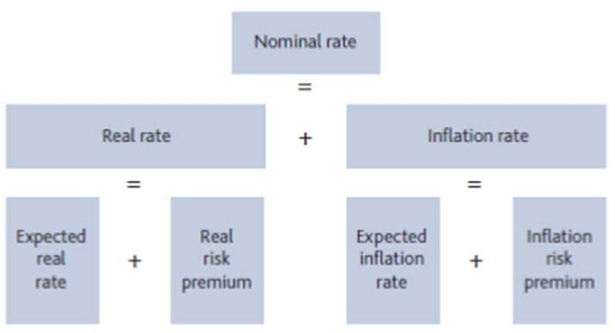

Source: Bank of England

So long-term rates can be higher than short-term rates because expected future real rates are higher than current real rates, or expected future inflation is higher than current inflation, or because investors demand a high real term premium, or because investors demand a high inflation risk premium.

I will now discuss what drives each of these components in turn. The expectations component of the yield curve, ie the extent to which future real rates are expected to be above or below current real rates, is closely linked to the economic cycle. In a downturn, the central bank cuts short-term interest rates to low levels, but after some years the interest rate is expected to revert back to a higher level, that will be appropriate when the inflation is at target, there is no slack in the economy and growth has returned to trend.3 Conversely, during an economic boom, when growth is above potential but there is little slack and inflation pressures are

2 For a detailed general discussion see Guimarães (2012) and Vlieghe (2016).

3 See the discussion on the equilibrium interest rate in Box 6 of the Inflation Report of August 2018.

building, the central bank might raise short-term rates to levels above those expected to prevail further out. In simple terms, a weak economy will therefore have a steep yield curve, and a strong economy will have a flat or even inverted yield curve, simply due to the expected future path of interest rates.

Next, I turn to the risk premium, or term premium, component of the yield curve. Finance theory tells us that the risk premium that any investor demands on an asset is related to how the returns on that asset vary with consumption.4 Intuitively, investors like assets that have high returns when consumption is low, i.e. high returns when economic activity is depressed. So investors will accept a low or negative risk premium on such assets. Such assets have insurance-like properties: they pay out more in bad times, when investors need it most. Investors dislike assets that have low returns when economic activity is depressed, and will therefore demand a high risk premium on such assets. So the key driver of risk premia is the covariance of asset returns with consumption growth, which simply means the extent to which an asset has insurance-like properties.

In the case of government bonds, long-term expected returns depend on future short-term real interest rates, as well as future inflation. So the risk premium will depend on how both of these are expected to vary with future consumption.

The insurance benefit of long term bonds as compared to short term bonds depend on how persistent consumption growth is. Short-term real interest rates tend to fall when the economy is weak, pushing the price of real bonds up. If consumption growth is persistent, i.e. if weak current consumption growth tends to be followed by weak subsequent consumption growth as well, then risk-free real rates will tend to be persistently low as well. If that is the case, the return on real long-term bonds will rise by more than the return on real short-term bonds during a period of low consumption growth. Real long-term bonds therefore provide, other things equal, more insurance value than real short-term bonds if consumption growth is persistent.

The more persistent consumption growth is, the more negative the real term premium will be.5 In other words, long-term real bond returns should, on average over the cycle, be lower than short-term real bond returns when consumption is persistent.6

Next, let us think about the inflation risk premium. Investors need to be compensated for the risk that future inflation turns out differently from today’s expected inflation. Again, the covariance point is key: investors will demand an inflation risk premium if inflation surprises on the upside (eroding the real returns on nominal bonds) precisely at the time when consumption growth is weak. And the inflation risk premium will be higher if inflation is persistent, i.e. if inflation drifts away from its previously expected level for a long time. If, instead, inflation surprises on the downside when consumption growth is weak, the inflation risk premium should be negative.

4 See my discussion in Vlieghe (2017). For a general textbook treatment see Campbell (2018).

5 For general treatments see Campbell (1986); Breeden (1986); Backus, Gregory and Zin (1989); Chapman (1997); Abel (1999); and recent overview of Campbell, Shiller and Viceira (2009). UK estimates include Evans (1998); Seppala (2004); Joyce, Lildholt and Sorensen (2010); Guimarães (2016); for US see Chernov and Mueller (2012) and D’Amico, Kim and Wei (2018). The real premium is only positive if there is negative autocorrelation in consumption growth.

6 This is indeed what Guimarães (2016) finds for the UK using robust decompositions of the nominal and real yield curve. Chernov and Mueller (2012) find similar estimates for the inflation term premium in the US (high in early 1980s and near zero or negative in the 2000s).

So the two key variables that determine the size of the inflation risk premium are the covariance of inflation with consumption growth and the persistence of inflation itself. Negative covariance and high inflation persistence hurt investors most, therefore requiring the highest inflation risk premium.

# Long run analysis of the yield curve and its drivers

I now turn to long run data on consumption, inflation, short-term and long-term rates7 to see to what extent the theory is supported by the data. The benefit of looking at a long sample is that there is more variation of the separate theoretical drivers, allowing a cleaner test of the theory.8 The bottom line from the evidence I review below is that the theory works very well in practice. In particular, the periods of increasing and persistent inflation, with negative covariance with consumption growth, such as the late 1970s and early 1980s, were the periods of highest term premium. Periods with stable inflation, and with positive covariance with consumption, as we experienced in the last two decades, as well as the gold standard era, were periods of low or negative term premium.

A first cut of the data is to compare the UK term spread between two long samples that had on average very different values of persistence and covariance, namely the gold standard era, and the post-gold standard era (after 1931).9 I then look at the variation over time in more detail within the past century.

# Table 1. Term spread and macro fundamentals during and after the Gold Standard

|  |  |  |  |  |  |  |
| --- | --- | --- | --- | --- | --- | --- |
|  | Mean Inf(1) | Con(2) | Term(3) | Autocorrelation  Inf Con | | Correlation  Inf, Con |
| GS (1831-1914) | 0 | 0.8 | -0.2 | 0.1 | -0.1 | 0.2 |
| Post GS (1931-2016) | 5 | 1.9 | 1.2 | 0.8 | 0.5 | -0.2 |

Notes: (1): Annual percentage change in GDP price deflator; (2): Real per capita consumption annual growth; (3): Term spread is the difference between the consol rate and short term market rate.

Source: BoE Millennium of Macroeconomic Data, Bank Calculations, Bank calculations

As shown in **Table 1**, during the gold standard, the term spread was, on average, slightly negative at -20bp. In the more recent period, the term spread averaged around 120bp. So the sum of real and inflation risk premia was significantly higher in the more recent period compared with the gold standard.

How does this compare with the theoretical drivers of the term premium, namely the persistence of consumption and inflation, and their covariance? During the gold standard, consumption growth showed little

7 It is only in recent decades that countries have started issuing real, i.e. inflation-linked, government bonds systematically, allowing us to observe long-term real bond returns distinctly from long-term nominal bond returns. Before that, most bonds were nominal, so returns on real bonds were not observable separately. In my longer-term analysis, I will focus on the total risk premium on nominal long-term bonds, which is the sum of the real premium and the inflation premium.

8 A second reason for relying on long time periods is because, over such long periods, it is reasonable to consider that expectations of future short-term rates will, on average, be equal to short-term rates, i.e. there is no systematic expectation that interest rates in the future will be different from those in the short term. That allows us to interpret the term spread, averaged over a long period, as reflecting risk premia rather than differences between the current short-term rate and expected future short-term rates. The term structure estimates using the available term structure data from 1971 and state-of-the-art models confirms this conjecture for the period 1972-2017.

9 See Vlieghe (2017) for details on data and further description of the behaviour of asset prices during and after the Gold Standard.

persistence, as did inflation, and inflation was on average zero. When neither consumption nor inflation are persistent, the risk premium on long-term bonds should be around zero, as indeed it was in the data. After an inflation surprise, inflation is not expected to drift, i.e. it is expected to return to its previous rate, so long-term nominal bonds are not subject to higher inflation risk than short-term nominal bonds. And with little consumption persistence, long-term real bonds do not provide much additional insurance relative to

short-term real bonds, because consumption growth and therefore short-term rates are expected to return to their averages relative quickly.

But in the more recent period starting in 1931, inflation and consumption became more persistent, and inflation rates trended up. The autocorrelation of inflation, a measure of persistence, rose from around 0.1 to around 0.8. Moreover, consumption growth and inflation became negatively correlated with each other, so periods of high inflation were also periods of low consumption growth, on average. So inflation tended to hurt investors precisely when the economy was depressed, and the inflation pain tended to be persistent. That made long-term nominal bonds far riskier than short-term nominal bonds, and investors demanded higher average returns to compensate for that risk: the average term spread rose to 120bp from slightly negative. 10

So far, we have just looked at the post 1930s period as a single period. But in fact, there were substantial variations in the monetary regime *within* that period, notably joining the Bretton Woods exchange rate regime in 1946 (followed by periodic devaluations), breaking up of Bretton Woods in 1971, the start of inflation targeting in 1992, and the resumption of operational independence of the Bank of England and the creation of the Monetary Policy Committee in 1997. Benati (2008) has documented that the persistence of inflation was influenced by these different monetary regimes. Persistence rose somewhat after the gold standard was abandoned in 1931, but rose much more sharply when Bretton Woods effectively ended in 1971. With no clear nominal anchor for UK monetary policy, inflation drifted very far from any notion of price stability in the 1970s and 1980s. Only when inflation targeting was adopted in 1992 did inflation re-anchor.

To assess the implications of these changes for the term premium, we also need to examine what happened to the covariance between inflation and consumption growth within the post-1930s era.

**Figure 1 and 2** shows the time-varying long run mean and persistence of inflation estimated for England since the 1300s, to show just how unique the persistent drift up in inflation in the 1970s was. This analysis highlights yet again that the 1970s-1980s were unusual in the big sweep of history.11 These were times when nominal bonds were unusually risky.

10 The autocorrelation of consumption became positive in the post 1930s period, rising from -0.1 to 0.5. That should lower the real risk premium, because long-term real bonds pay off more when consumption growth is low. Because of the absence of inflation-linked bonds for most of the period, we can only measure the sum of the real risk premium and the inflation risk premium, not its separate components. So I infer that the rise in the inflation risk premium was far bigger than the decline in the real risk premium, resulting in the total term premium going up by 120bp.

11 See my discussion of real rates in Vlieghe (2017).

# Figure 1. Implied long run mean of inflation from UCSV- TVP model – England 1371-2016

**Figure 2. AR(1) coefficient on inflation from UCSV-TVP model – England 1371-2016**

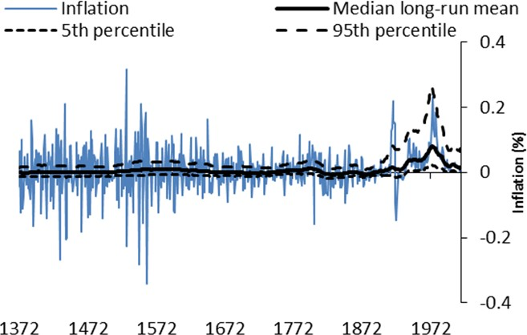 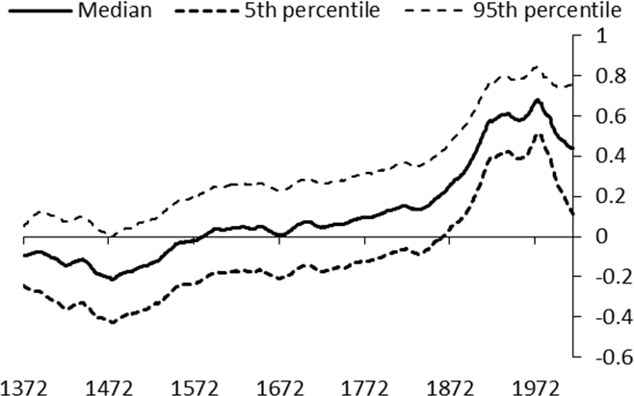

Note: Figures 1 and 2 show the long-run mean and AR(1) coefficients from a Stock and Watson (2007) Unobserved Components Stochastic Volatility (UCSV) model with time-varying coefficients. The solid black line shows the median estimates, and the dotted black lines show the 5th and 95th percentiles of the posterior distribution.

Source: BoE Millennium of Macroeconomic Data, Bank calculations

Not only was inflation persistent and with a rising trend, but it had the most negative covariance with consumption growth in its history, meaning that inflation tended to hurt investors most when consumption was already low. Negative supply shocks had persistent effects on inflation, as the nominal anchor for monetary policy was weak or absent.

**Figure 3** shows simple rolling estimates of the correlation between inflation and consumption growth. It shows the correlation steadily declined in the post 1930s, becoming more negative. It was only in recent decades that it became positive again, resembling the correlation that prevailed during the gold standard.

# Figure 3: Co movement: 30-year rolling window correlation of inflation and consumption

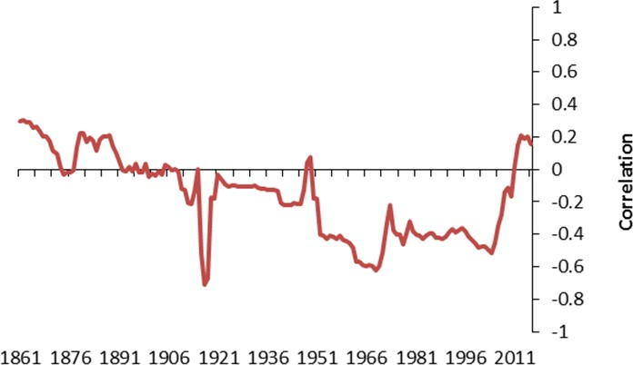

Source: BoE Millennium of Macroeconomic Data, Bank calculations

With trend inflation low and stable after inflation-targeting and independence, and inflation correlation with consumption positive again, one would expect long-term bonds to have a term premium that is close to zero or negative, after a period of a strongly positive inflation risk premium in the 1970s and 1980s.

That is exactly what we find in the data. **Figure 4** shows estimates from term structure models that incorporate the information in surveys of professional forecasters about expectations.12 The term premium on 10y government bonds is estimated to have been positive for the 1972-1996 period, before falling to slightly negative after Bank of England independence in 1997. Moreover, today’s levels are not that different from the pre-crisis 1997-2007 average. (See Table A1 in the appendix).

The fact that we are able to understand the decline in term premium since the 1980s using only the deep fundamentals of inflation persistence and inflation correlation with consumption means that we do not need to appeal to extraordinary circumstances or the impact of unconventional monetary policy as an explanation. I will return to that in sections 3 and 4.13

# Figure 4: Range of 10 year spot nominal term premium estimates (different samples and number of factors)14

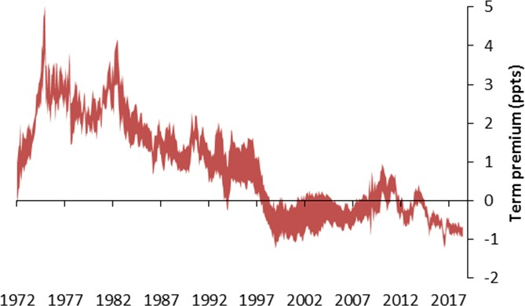

Sources: BoE, HMT, updated models estimates from Guimarães (2012, 2016)

I am not making a forecast that the term premium will never rise again. First, the term premium moves around over the cycle, just like risk premia on other assets. I am only making a point about where we should expect it to be on average now. Second, I am arguing that we would need to see a change in the inflation risk fundamentals to see a large and sustained increase in the term premium. That in turn will depend on both the shocks hitting the economy, and how the MPC responds to those shocks. But even before the

12 See Guimarães (2012, 2016) and Vlieghe (2016) for detailed discussion.

13 Persistence and correlation have moved in similar ways in the US. The US yield curves have behaved very similarly to UK, as discussed in Vlieghe (2016), with the important difference that the Fed only recently adopted an explicit inflation target, hence their perceived target drifted lower over time, in contrast to the more sudden anchoring in the UK following the adoption of inflation target and independence.

14 The range includes a total of 69 estimates, with models of 3 to 5 factors estimated over 23 different samples (varying start and end date) each. This is an update through July 2018 of the range shown in Vlieghe (2016). See Guimarães (2016) for a full discussion. Figure A3 in the appendix shows the range for the same combination of estimates (number of factors and sample choices) when no survey forecast information is used.

financial crisis and ensuing period of QE and policy rates at their effective lower bound, the term premium was roughly where it is now in the UK, so just a return to pre-crisis normal would not mean a significantly higher term premium than where we are today15. As I have mentioned before,16 the decline in long-term yields relative to the pre-crisis period that can be attributed to the term premium is measured in tens of basis points, not hundreds of basis points.

# How does conventional and unconventional policy work?

Before turning to the specifics of QE and the yield curve, I want to recap more broadly how I think QE works as an instrument of monetary policy.

It is important to emphasise that, conceptually, QE is not that different from conventional monetary policy. Conventional monetary policy and QE both involve open market operations: purchases and repos of government bonds and other financial instruments, in exchange for central bank reserves. The difference is only in emphasis and scale: conventional monetary supplies the necessary reserves to achieve a particular level of a very short-term interest rate (in the case of the UK, the target of conventional policy was the SONIA rate that prevails from one MPC policy decision to the next one).17 But the wider objective of policy is that such changes in very short-term money market interest rates affect a wide range of other interest rates and other asset prices, which in turn affect growth and inflation. QE policy also supplies reserves, but

de-emphasises the impact on the very short-term money market rate18, which is typically at its effective lower bound when QE is deployed. Like conventional policy, QE policy also aims to affect a wide range of interest rates and other asset prices, which in turn affect growth and inflation. Both conventional policy and QE policy are deployed with the aim of keeping inflation close to target.

It has long been understood19 that the key mechanism by which conventional policy affects the economy is not the direct effect on the economy of very short term money market rates, which is small. Rather, changes in policy rates affect not just current money market rates, but also expectations of future money market rates, which in turn affect mortgage rates, corporate bond rates and a whole range of asset prices that are important for the economy. If market participants thought that a change in the policy rate today was going to be reversed next month, today’s change would have very little impact. The powerful impact from monetary policy is that today’s action influences expectations of future actions, because policy rate changes and the accompanying communication reveal the central bank’s reaction function. There is a close parallel with QE:

15 One additional subtlety about the behaviour of inflation in the post-crisis years might have played a role: in the UK and other advanced economies, the post-crisis recoveries have been characterised by weaker than expected inflation pressure during a period where the effective lower bound on interest rate has been binding. That has led to persistent fears of low inflation coinciding with low consumption growth, which should push the term premium more deeply into negative territory. Given we expect r* to remain lower than pre-crisis for the foreseeable feature, the likelihood of being at the ELB has increased which might lead to a more negative term premium than pre-crisis.

16 See Vlieghe (2016).

17 See The Bank of England’s Sterling Monetary Framework (2015), known as the Red Book [www.bankofengland.co.uk/markets/Pages/sterlingoperations/redbook.aspx](http://www.bankofengland.co.uk/markets/Pages/sterlingoperations/redbook.aspx)

18 Through the operation of a floor system for reserves since the introduction of QE, the link between short-term interest rates and reserves has been weakened, in the sense that oversupply of reserves does not preclude control over short-term interest rates. But we should not forget that it is only the existence of *some* bank demand for central-bank provided reserves that permits central bank control over short-term interest rates. And I believe it is still useful to think of monetary policy as having an important impact via the quantity of aggregate money and credit, not just via interest rates (eg see “Money Creation in a Modern Economy”, Bank of England Quarterly Bulletin 2014 Q1).

19 See the synthesis in Woodford (2003), who says “Not only do expectations about policy matter, but, […] very little else matters” (page 15).

today’s purchases of government bonds send a clear signal that the central bank deems adding more stimulus is necessary, with the size and pace revealing the amount of stimulus, even though the policy rate is at or near its effective lower bound. That influences expectations of future monetary policy, as QE is a powerful signal that a central bank is not minded to raise rates any time soon, since it just voted to add even more stimulus.

I prefer calling this an “expectations channel” rather than a “signalling channel” because the signalling channel is usually interpreted more narrowly as just providing information about the future path of rates. By “expectations channel” I have in mind a broader mechanism that informs people about the future path of interest rates, but also about the reaction function: how the central bank responds to news, conditions under which further QE might be deployed, tolerance for temporary above-target inflation when the output gap is large.20 Just like with conventional policy, both the actions and the communication are important in determining the impact on the economy and asset prices.

It is important to note that my assessment that both conventional policy and QE work largely via expectations does not mean they have no effect on term premia or risk premia of other assets. There is a large body of evidence that conventional policy affects all kinds of asset prices: long term bonds, credit spreads, equity prices, and exchange rates.21 Monetary policy changes the outlook for the economy and the balance of risks, so there is every reason to think it should also have an impact on risk premia. And QE can be expected to have similar effects, even if both conventional and QE policy work primarily via expectations. If this description of conventional monetary policy sounds unfamiliar it is because textbook macro models tend to ignore risk premia, which finance theory tells us are crucial to understand any asset price.

One argument that some are tempted to make, but I want to dismiss, is the following: if QE policy is all about influencing expectations, why not just stick to forward guidance? Forward guidance merits a place in the monetary policy toolbox, but there are two reasons why QE and forward guidance are not perfect substitutes.

Unlike forward guidance, QE does have important direct effects, even if they are less well understood than in the case of conventional policy. First, purchasing a large quantity of any asset in a short space of time pushes up the price, even if only temporarily. Second, QE improves aggregate liquidity by increasing reserves at a time when aggregate liquidity is scarce. Third, QE can target specific assets for which buyers are scarce.22 Once orderly market function has been restored, these liquidity effects fade away, but they are crucial at a time of financial stress23. Finally, the demonstrated commitment to avoiding deflation by adding to the money supply may also help anchor inflation expectations.

A second reason why QE and forward guidance are different is that the impact on expectations from QE comes from taking a policy action today, not just talking about policy action in the future. To see this more

20 See Carney (2017).

21 See Bernanke and Kuttner (2005); Alvarez , Atkeson and Kehoe (2009); Gorodnichenko and Webber (2015); Bekaert, Hoerova and Duca (2015); Lucca and Moench (2015); Hanson and Stein (2015); Boyarchenko, Haddad and Plosser (2017); Javadi, Nejadmalayeri and Krehbiel (2018); Nakamura and Steinsson (2018); Inoue and Rossi (2018).

22 Examples include the purchases of mortgage-backed securities in the US and corporate bonds in the UK.

23 Note that the added liquid assets do not disappear, but their effect on markets and the economy disappears. Hence the liquidity *effect*

is temporary.

clearly, imagine arguing, in normal times, that we can set policy by talking about future interest changes, while keeping current interest rates always unchanged. Everyone would see through that pretty quickly: if talk about future changes is never accompanied by current changes, it will soon cease to have an effect. The absence of policy action, in the case of pure forward guidance that is not accompanied by action validating the guidance, inevitably invites doubts about the future action irrespective of how it is communicated, rendering it less powerful than immediate action.

Having set out how I believe QE works, let me now provide some evidence that it does work. One striking illustration of the impact of QE is given by the different experience in the early phases of QE in the UK and US on the one hand, and Japan on the other hand. Japan was the subject of much criticism by leading macroeconomists for not doing enough to avoid a deflationary trap in the 1990s and 2000s.24 Yet the path of nominal rates, both short-term and long-term, was incredibly similar in the early stages, as seen in **Figures 5 and 7**. These similar changes across the nominal yield curve took place despite the fact the US and UK resorted to asset purchases early on, while Japan only pursued similar policies more than a decade later, having raised policy rates briefly in the intervening period.25

The difference was the path of inflation, and more importantly, inflation expectations.26 While inflation expectations remained relatively anchored in the US and UK, they drifted lower in Japan early on, and remained stuck at low levels (**Figure 6**).27 The absence of more decisive action caused doubt about the BoJ’s commitment to fighting disinflation, and as a result, inflation expectations drifted lower. This meant that, for similar nominal rates, real rates were much higher in Japan, i.e. policy was less stimulative, entrenching the low inflation expectations. Eventually, lower inflation expectations brought down nominal yields in Japan by even more than in the US and UK, despite the fact that Japan did not buy long-term government bonds over the period shown in the chart.

A similar picture emerges in the Eurozone following the interest rate hikes in 2011 and the absence of QE in the initial phases of the downturn. As shown in **Figure 8**, inflation expectations began to drift lower from 2014 onward. It was only when the ECB committed to QE that inflation expectations started to recover, allowing real rates to fall lower and therefore be more stimulative, which in turn reinforced the drift up of inflation expectations back towards target.

24 See for example Bernanke (2000).

25 Figure 7 shows that the US and UK cut interest rates by more, earlier in the easing cycle. One further difference that the charts above do not show is that the US and UK started the easing cycle much earlier than the ECB and Japan. The US started the easing cycle in October 2007, just 3 months after the start of the stock market decline, and the UK in December 2007, whereas the ECB only began in November 2008 (more than a year after the start of the crisis, by then stock markets had fallen by more than 40%) and Japan only began easing in July 1991, though the stock market peak was in December 1989 and the stock market had fallen by more than 40% by July 1990.

26 See Boneva et al (2017) for effects of QE on inflation expectations in the UK. They do not find similar effect for forward guidance.

27 Short-term inflation expectations show the Euro Area was somewhere in between the anchoring seen in the US and UK and the de- anchoring of inflation expectations in Japan.

# Figure 5: Change in policy rates since start of easing cycle that led to ELB

**Figure 6: 10 year expected inflation since start of easing cycle that led to ELB**

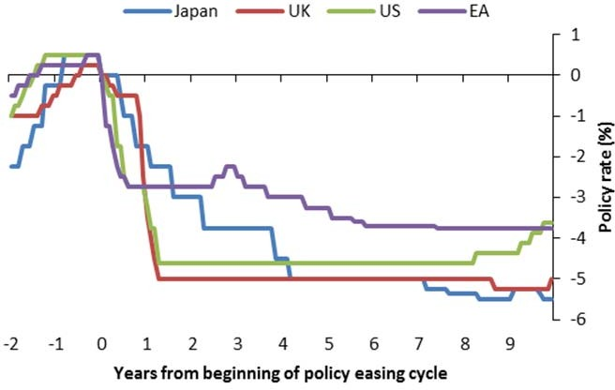 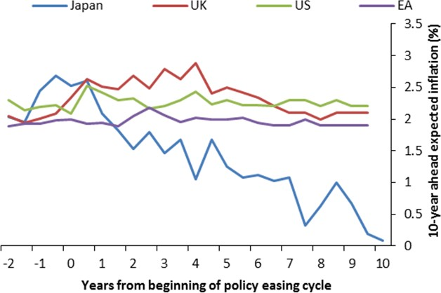

Source: Reuters DataStream, Bank calculations Source: Consensus Forecasts, Bank calculations

# Figure 7: 10 year yields since start of easing cycle that led to ELB

**Figure 8: Euro Area policy rates and term structure of inflation expectations**

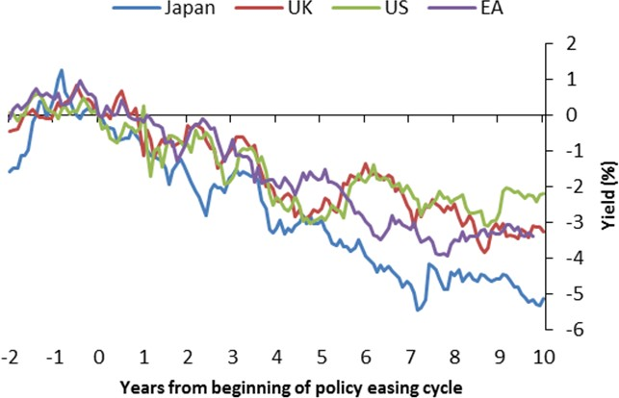 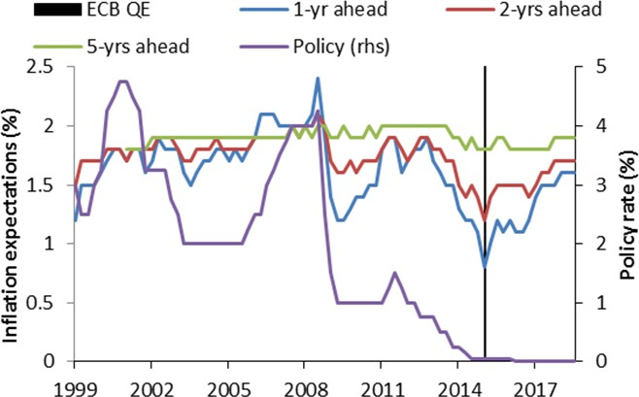

Sources: BIS, FRED, Bank of England, ECB, Bank calculations Source: ECB

I have argued that QE works mainly by influencing expectations of future monetary policy, underpinned by the strong signal that immediate policy action sends about the central bank’s reaction function and its assessment of the economy, as well as by strong liquidity effects during times of financial stress.

I would now like to contrast this view of how QE works with the “portfolio balance” view as used in much of the literature analysing QE so far. The portfolio balance view of QE is mostly based on the work of Vayanos and Vila (2009), which introduces “preferred habitat” investors (inelastic demand investors) along

with myopic arbitrageurs to examine the role of the quantity supplied of particular bonds28. Applied to QE, the theory says that, by buying large quantities of government bonds, the central bank bids up the price of government bonds by compressing their term premia, which reduces long-term interest rates. In turn, the reduction in long-term interest rates via lower term premia pushes up other asset prices and stimulates economic activity. Everything else equal, the preferred habitat theory implies a permanent decrease in the real term premium following a permanent reduction in net supply.

Much of the literature29 on the effects of QE that uses the portfolio balance framework finds evidence that is consistent with such a framework, but, as is often the case in economics, also permits other interpretations. Moreover, some patterns in the data are plainly inconsistent with the framework, and I will highlight four.30 My view is that, thinking about QE as working through expectations and temporary liquidity effects instead, runs into fewer inconsistencies with the data, but of course, that does not constitute definitive proof in favour of my own view. Significant uncertainty remains about the precise channels through which QE works.

The first challenge is shown in **Figure 9**. Long-term forward rates – which are the rates that are affected more in the portfolio balance channel – did not move much in the early stages of QE, which is also the period when the high-frequency evidence in favour of portfolio balance effects suggests it had the strongest impact.31 Initially, at the depth of the crisis, forward rates stayed persistently high. When it gradually became clear that the recovery would be slow and protracted, so short-term interest rates would not swiftly return to pre-crisis levels as was expected early on, only then did forward rates decline significantly relative to pre- crisis levels.32 As I described in an earlier speech (Vlieghe (2016)), the behaviour of forward rates resembles a “lying down” of the curve, with the date of rising rates being pushed out further over time and reaching a lower end point as time went by, which essentially reflected the evolution of expectations.33

28 Either quantity supplied or aggregate duration supplied, as in Greenwood and Vayanos (2014). Greenwood and Vayanos (2014) find smaller effects than most QE studies (see Williams (2013)), and their identification of significant effects of quantities on bond yields and returns has been questioned by Bauer and Hamilton (2018) and shown to be insignificant during the ELB period by King (2018).

29 This includes the event studies (e.g. Joyce et al (2011) for the UK and Gagnon et al (2011) for the US); panel studies using bond specific amount purchased by central banks (D’Amico and King (2013) for the US and Joyce and Tong (2012) for the UK); and a number of VAR studies (e.g. Kapetanios et al (2012), Baumeister and Benati (2013) and Weale and Wieladek (2016)). Importantly, the first and third strands (event studies and VAR) use the portfolio balance theory indirectly to interpret their results, with nothing in their methods that would unambiguously identify this mechanism versus alternatives. One identification used is that conventional policy should not affect long term rates, which is contradicted by the evidence (e.g. Hanson and Stein (2015) and Nakamura and Steinsson (2018)).

30 I have discussed these issues before in Vlieghe (2016), including some additional evidence on the term premia vs. expectation components contribution for the post-crisis period. Some of the points I raise have been raised also by some of the leading authors of preferred habitat models. For instance, Greenwood and Vayanos (2010) acknowledge that the effects maybe transitory and that it is important to account for variation in arbitrageur capital, which is what I have in mind when I refer to the effects of QE as liquidity effect: temporary price pressure that is largely temporary, with the magnitude and persistence of the price pressure depending on both the level of aggregate liquidity – i.e. arbitrageur capital – and size of quantity changes). Greenwood also separately shows (1) event studies are not reliable in identifying the supply effects in segmented markets (Greenwood, Hanson and Liao (2018)) and (2) the challenge that accounting for aggregate supply changes in this period (not just QE) poses to the view that QE has lowered term premia (Greenwood, Hanson, Rudolph and Summers (2014)). The importance of a signalling channel has also been raised by others (e.g. Krishnamurthy and Vissing-Jorgensen (2011) and Bauer and Rudebusch (2014)).

31 See the discussion in Haldane et al (2016) and Broadbent (2018) for the UK, and Greenlaw et al (2018) for the US.

32 This is not only true for the UK – a similar point can be made with US yields. See Figure A2 for the similar charts as Figure 9 for the US.

33 Table A1 in the appendix updates the analysis in Guimarães (2012).

# Figure 9: Evolution of UK 1-year forward rates relative to pre-crisis average

UK Gilts: 1-year,0-year forward UK Gilts: 1-year,1-year forward UK Gilts: 1-year,2-year forward

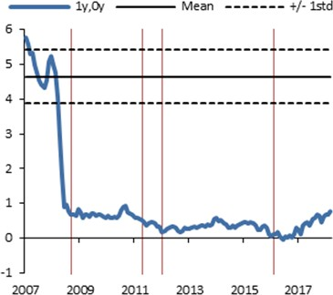

QE1 QE QE3

QE4

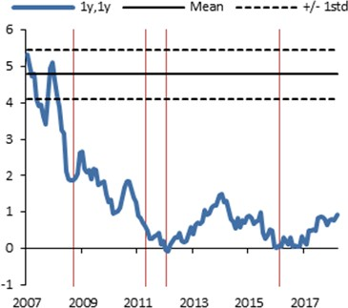

QE1

QE2 QE3

QE4

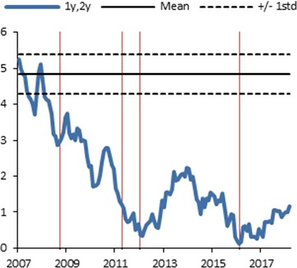

QE1

QE2 QE3

QE4

UK Gilts: 1-year,10-year forward UK Gilts: 1-year,15-year forward UK Gilts: 1-year,20-year forward

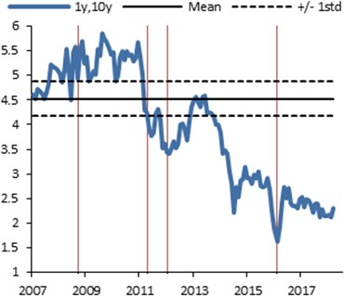

QE1 QE2 QE3

QE4

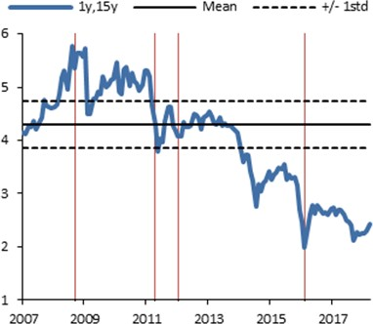

QE1

QE2 QE3

QE4

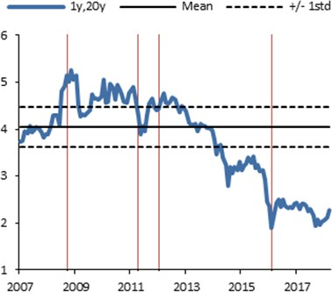

QE1

QE2 QE3

QE4

Notes: Mean and standard deviation are calculated for each security between January 2000 and July 2007 Source: BoE calculations

Second, the portfolio balance channel relies on a direct effect of the net quantity of bonds that the private sector needs to absorb. By reducing that quantity, the central bank is supposed to reduce risk premia. But the quantity of government bonds that the private sector needed to absorb after accounting for the purchases by central banks (shown in **Figure 10**) went up drastically during the crisis and stayed high, as the increased bond supply required to finance deficits far outstripped central bank purchases.34 So one could argue that the portfolio balance channel prevented risk premia from going up even more, but it cannot logically be an explanation for the general decline in yields since QE started. Moreover, the magnitude of the rise in net supply of government bonds in the early part of the crisis, and the contemporaneous rise in term premium during that period (between 2008 and 2010) suggests a small and temporary quantity effect, rather than a large and permanent one: supply has stayed high while the term premium completely unwound the rise in the 2008-2010 period.35

34 A point also made by Greenwood, Hanson, Rudolph and Summers (2014) for the US.

35 The average maturity of debt also went up, suggesting that a duration channel (see Greenwood and Vayanos (2014)) would also point to higher term premia if these mechanical quantity channels were dominant and persistent.

Third, much of the evidence of the direct impact of QE on yields comes from short window event studies: analysing the change in yields around the time when the central bank made official QE announcements or took QE actions. These event studies allow us to abstract from all the other economic and financial events that generally tend to move yields, and isolate the impact of QE. But, as I and many others36 have pointed out, the announcement effects are still subject to possible biases. The method could underestimate the impact of QE, if financial markets partially anticipate the announcement, or if it takes time for the market to digest the announcement. Conversely, the method could overestimate the impact of QE, if QE has temporary liquidity effects that die out quickly.37

# Figure 10: Net supply of UK debt and 10-year spot term premia

Note: “All gilts” include both nominal and inflation-linked bonds; “Conventional gilts” include only nominal bonds. Solid lines show free float (% GDP); while dotted lines show free float (% GDP) minus Asset Purchase Facility purchases.

Source: DMO, ONS and Bank calculations

Greenwood, Hanson and Liao (2018) extend the Vayanos and Vila (2009) and Greenwood and Vayanos (2014) models to a world with two markets and slow-moving capital between them. Their model implies that event studies are not able to identify the real effects of shocks to quantities in one market, as the market initially affected will overreact in the short term.

36 For a general discussion see Gurkaynak & Wright (2013). In an extension of the Vayanos and Vila (2009) model to an economy with two markets, Greenwood, Hanson and Liao (2018) show that event studies *will not* correctly identify the quantity effects on prices, irrespective of the length of the window around the announcement.

37 Greenlaw, Harris, Hamilton, West (2018) raise concerns that announcement effects are biased upward because the researchers overly focus on a few announcements that have had large effects, ignoring others that have had little effect. Arguments that QE became part of the central bank reaction function are exactly the argument we are making, which would then imply that the effect is not only about the mechanical quantity effect as predicted by the preferred habitat theory, but also about the central bank’s reaction function.

Studies that use micro data to identify local supply effect (D’Amico and King (2013) for the US and Joyce and Tong (2012) for the UK) are subject to the Woodford(2012) criticism that if the effect of QE is mostly to affect relative pricing of close substitute bonds (which is the implication of their findings of significant effects and lack of any clear effects in the time series) then it has no relevance for macroeconomic outcomes. See also Krishnamurthy and Vissing-Jorgensen (2013).

# Figure 11: Cumulative response of 10 year spot yield to all UK QE announcement dates

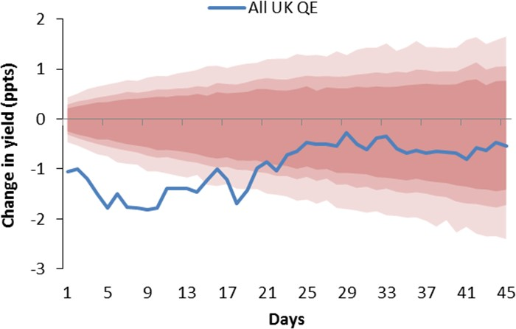

Note: The blue line is the cumulative response of the 10-year spot yield to all UK QE events. The light, medium and dark red- shaded areas denote the 99%, 95% and 90% confidence internal respectively.

Source: BoE, Bank calculations

To analyse the reliability of event studies, I re-run this type of analysis, but show in **Figure 11** the response of yields not just on the day of the announcement, but in the 30-day subsequent window.38 There is a clear pattern here that shows that much of the effect tends to die out very quickly, which is why it is impossible to spot any effect from QE in the time series of long forwards shown in **Figure 9**. This is not definitive proof of anything, but it is much more consistent with a short-lived liquidity effect than with a persistent portfolio balance effect.39 In contrast, the “lying down” pattern of the yield curve, reflecting a change in expectations, happened slowly and persisted.40

Fourth, studies that use data on investor positions and broad wealth to investigate these quantity channels along with other channels (including expectations), tend to find very small effects.41 A recent Eurozone study by Koijen et al (2018) uses the most comprehensive and detailed information on the asset holdings of individual investors to examine the effects of QE in the Eurozone. They find that (1) the impact on government bond yields directly attributable to QE in the first 22 months of the ECB purchase programme is

38 Figure 11 shows the sum of changes in 10-year spot yield across all the identified QE events outlined in Appendix table A3. To avoid the double counting of responses in the aggregate, I use non-overlapping windows in the individual responses. Individual announcement date charts are shown in the Table A4 in the appendix. Confidence bands are obtained using the bootstrap procedure proposed by Mamaysky (2018).

39 Wright (2012) finds little persistence. Swansson (2018) also shows no persistence when March announcement is included (15 days half-life). Only if March is excluded, which accounts for almost all of the effect in event studies, does he find evidence of persistence. But without the March announcement the LSAP factor Swansson (2018) extracts is very similar before and after LSAPs ever took place, so implicitly also making the case that QE is like conventional policy – though he doesn’t say this.

40 See Table A2 in the appendix.

41 See Piazzesi and Schneider (2008), who allow both a quantity and expectations channel in their study, and find that the quantity effect is small. This stands in contrast to the much of the literature on effects of QE which does not model quantities and expectations jointly. Moreover the Vayanos and Vila (2009) model and its extensions (see Greenwood, Hanson and Vayanos (2015)) assume that the short rate factor and quantities are independent, which is clearly inappropriate for evaluating QE. To capture this explicitly, King (2018) extends the Vayanos and Vila (2009) to include the ELB using the “shadow rate” framework and finds larger effects from changes in expectations than quantity effects in the US.

small, at only 13bp; (2) they find no evidence at all that domestic inelastic investors tend to switch to riskier assets after they sell their bonds to the central bank.

One way to reconcile the permanent quantity effects, as implied by much of the QE empirical literature stressing preferred habitats and portfolio rebalance, with the temporary liquidity effects that I stress instead, is to extend the notion of slow moving capital in the two market model of Greenwood et al (2018) more generally, along the lines discussed in Duffie (2010). The idea of the slow moving capital literature is that arbitrageurs need time to raise capital, or might be temporarily constrained, which means large quantity changes can have large price effects until new capital flows in to the affected market. This is a more general way of capturing liquidity effects (meaning temporary price effects of large trades) economists have long known to exist. **Figure 12** shows a popular measure of bond market illiquidity for the UK and US, highlighting how the late part of 2008 and early part of 2009 was an extremely extraordinary period of low liquidity.

# Figure 12: Noise squared: Bond market illiquidity for US and UK government bonds

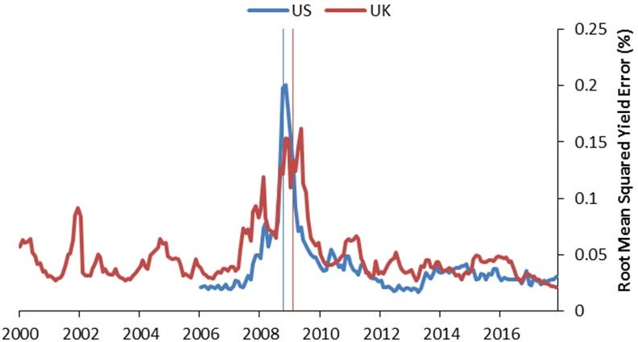

US QE1 UK QE1

Note: This measure of illiquidity shows the squared deviations of the bond yield from an estimated smoothed yield curve. Under this measure, a market is deemed illiquid if the squared deviations are high, as it suggests a shortage of arbitrage capital that usually plays an important role in keeping bond yields ‘close’ to the curve. See Hu, Pan and Wang (2013) for further information.

Source: BoE, Bank calculations

In the slow moving capital view, large quantity effects are mostly temporary, and larger when intermediaries are constrained, as in the financial crisis. But they have much smaller or no long run effects once intermediaries are unconstrained. Viewed from this perspective, QE effects would be larger in states of illiquidity, with little or no long run effects on term premium. In this sense it would not be different from

conventional policy42 in preserving long run neutrality: its role is to speed up recovery, not to affect the end point or have any permanent real effects (e.g. on term premium).43

# QE and the yield curve: what to expect from QE unwind

Let me recap briefly what we have learned so far. Low term premia are consistent with economic fundamentals, namely stable trend inflation and positive covariance between consumption and inflation. There is no need to appeal to a story of term premia being artificially compressed by QE to explain where we are today. QE policy works primarily via expectations of future monetary policy, with important liquidity effects which are temporary.

Why is it so important to distinguish views about how QE affects the yield curve? Because it will inform how policy works when QE is unwound.

A portfolio balance channel would be expected to work in a rather symmetric way: if the central bank compresses the term premium by a certain amount when buying assets, it would raise the term premium by a similar amount when selling assets. The economic impact should be symmetric as well.

But a QE channel that works via expectations along with temporary liquidity effects is not symmetric on the way in and on the way out.

Liquidity effects are far less important when markets functions well and its participants are well capitalised. This is consistent with the much smaller impact observed for the later rounds of QE relative to the initial announcements.44 And this would suggest that, as long as QE is unwound in a gradual and predictable way so as not to disrupt market functioning, liquidity effects on the way out should be negligible. This is precisely why the MPC has emphasised in its QE guidance that QE unwind will be “gradual and predictable” and “would take account of the need to maintain the orderly functioning of the gilt and corporate bond markets”.45

The expectations channel of QE is not symmetric either. When policy rates are at the effective lower bound, the central bank is no longer able to use changes in the policy rates to affect expectations of future monetary policy. A key instrument is lost. So the main policy tool becomes QE, along with continuing communication, as the new policy lever to affect expectations. But when the policy rate moves away from the effective lower bound, the central bank now has two levers with which to affect expectations. To avoid sending conflicting signals in the future, the MPC has made it clear that, once Bank Rate is around 1.5%, Bank Rate will once again become “the primary instrument for monetary policy”.46 This is important because it means that expectations of future policy rates can once again be influenced by changing current policy rates and continuing communication, exactly as was the case in pre-QE days. Provided this is well understood by

42 Further reinforcing the similarities, Brooks, Katz and Lustig (2018) find that conventional monetary policy also leads to portfolio balance effects that explain the momentum in bond yields following monetary policy shocks.

43 Long run neutrality implies the economy will end up in the same place (in terms of real variables – which includes term premia) irrespective of what monetary policy does. But even in a world with long run neutrality, monetary policy might reduce the temporary deviations from steady state, which is welfare improving.

44 See Meaning and Zhu (2011), Haldane et al (2016) and Broadbent (2018).

45 The MPC guidance on the unwind of QE was first provided in the November 2015 Inflation Report (p. 34) and updated in the June 2018 MPC Minutes.

46 Ibid.

households, businesses and financial markets, the unwind of QE should then have no additional effect on expectations, and therefore on the economy.

# Figure 13: US 10-year spot term premium

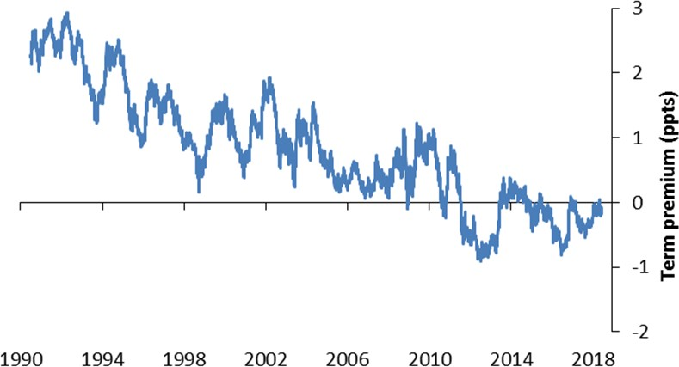

Source: Federal Reserve St. Louis (fred.stlouisfed.org), Kim and Wright (2005)

Emphasising the expectations and liquidity channels of QE rather than the portfolio balance channel allows a better understanding of recent yield developments in the US. Recall that the Fed started raising its policy rate in late 2015, while leaving the QE portfolio in place. Over the course of 2017, it began to communicate that QE would start to be unwound in the near future, and in October 2017 the unwind process actually began.

Over this period, the US yield curve flattened, and the term premium rose only slightly (**Figure 13**).47 Note that the QE unwind was even accompanied by significant news about increased government bond supply, given the fiscal easing currently taking place in the US. A portfolio balance story would have predicted large term premium effects. 48

While the term premium has been little changed, the yield curves in the US and UK have flattened significantly over the past few years. That has been largely driven by changing expectations of future interest rates, in response to changes in the economic outlook and actual policy rate changes.

47 Estimates from updated Kim and Wright (2005) model, which is a 3 factor model with survey information, one particular choice of number of factor and sample of those shown for the UK in Figure 5.

48 See Broadbent (2018), in particular his Chart 7, for a related discussion of the evidence so far from the US QE unwind.

# Figure 14: UK policy rate and 10-2 year slope in tightening cycles

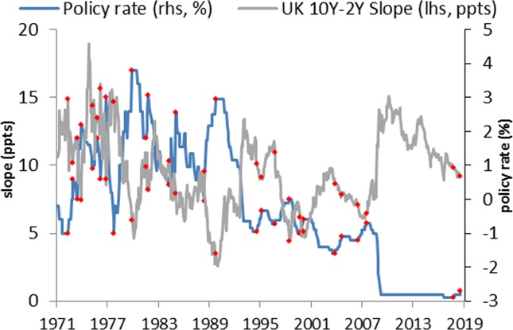

Source: BoE, Bank calculations

# Figure 16: US policy rate and 10-2 year slope in tightening cycles

**Figure 15: Change in 10-2 year slope per ppt change in policy rate in UK tightening cycles**

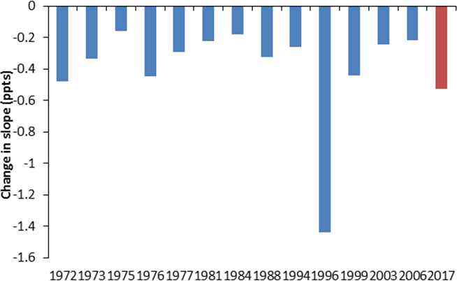

**Figure 17: Change in 10-2 year slope per ppt change in policy rate in US tightening cycles**

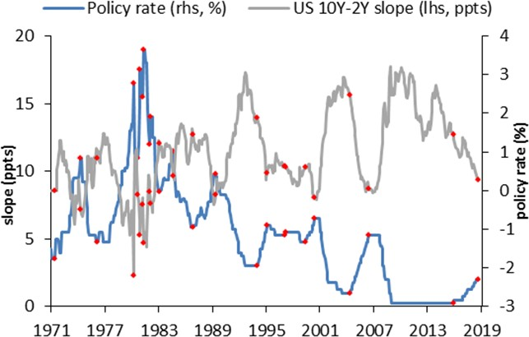 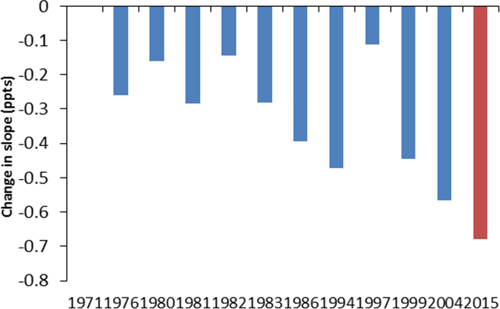

Note: The red dots in the LHS figures denote the beginning and end of each tightening cycle for policy rate (blue line)49. The red dots on the slope shows the corresponding slope at the beginning and end of each tightening cycle. The blue bars on the RHS figures show the change in 10-2 year slope divided by the corresponding increase in the policy rate (in ppts) in each tightening cycle, as defined by the red dots.

Sources: Fed St. Louis FRED, Bank calculations

**Figures 14 - 17** show the evolution of the yield curve slope against the evolution of the policy rate, for the UK and the US. It is entirely normal for the yield curve to flatten when the policy rate is rising, and for the yield curve to steepen when the policy rate is falling, as I discussed right at the beginning of this speech. Larger

49 As both Figures 14 and 16 show, policy cycles in the 70s and 80s are less clear than in the 90s and onwards. For the more recent 90s-present period, I define the beginning of a tightening cycle as the first increase in the policy rate after a significant period of decreases or no-changes, and the end of the tightening cycle as the last of the policy increases. In the 70s and 80s, I define a tightening cycle by identifying a large change in the policy rate, for which some judgement is required.

increases in short-term rates during a tightening cycle, with relatively more stable expected long-term rates, explain this pattern. As can be seen in the case of the US, the flattening in the yield curve in the current cycle, measured per unit of Federal Reserve conventional tightening, is quantitatively similar to the flattening that always tends to take place during tightening cycles. What has been crucial is the Fed’s careful communication around the QE unwind steps, so that they do not inadvertently send a signal about future monetary policy that they do not wish to send. The MPC has already taken important steps in this direction with its November 2015 guidance and the update in June 2018, and further communication can be expected as we approach the date when QE unwind is likely to start.

# Conclusion

The yield curve was upward-sloping, on average, in the 20th century. Holders of long-term bonds required higher returns, on average, than holders of short-term bonds. But the yield curve was flat before that, in the gold standard era. I argue that, since Bank of England independence, the fundamentals of inflation and inflation risk have become more similar to the gold standard era than to the 20th century average, and in particular are very different from the 1970s and 1980s. So we should expect yield curves to be flat again, on average. I argue that all of these changes in fundamentals and term premium were largely in place before QE started, so we do not need to resort to QE as a separate factor to explain the current shape of yield curves. Does QE not affect the yield curve? Of course it does. But it does so primarily by affecting expectations of future monetary policy, revealing the central bank’s reaction function. This anchors inflation expectations even when interest rates are constrained at the effective lower bound, which in turn affects a wide range of asset prices, economic growth and inflation. In that sense, QE is not that different from conventional monetary policy. I argue against the view that QE works primarily by pushing down long-term interest rates directly, through compressing the term premium (the “portfolio balance channel”).

Understanding the main channels through which QE works is going to be very important when it comes to unwinding QE: my view that QE works primarily via expectations, with additional powerful liquidity effects that are temporary and mainly relevant during periods of market stress, implies that unwinding QE need not have a material impact on the shape of the yield curve, or indeed on the economy, if properly communicated and done gradually.

# Appendix

**Table A1. Decomposition of nominal yields into inflation and real rates**

|  |  |  |  |  |  |  |  |  |  |  |  |  |
| --- | --- | --- | --- | --- | --- | --- | --- | --- | --- | --- | --- | --- |
| Nominal (level) | | | | | Inflation (level) 5y 5y,5y  spot fwd | | 10y spot | 9y1y fwd | Real  5y spot | (level)  5y,5y fwd | 10y spot | 9y1y fwd |
|  | 5y  spot | 5y,5y  fwd | 10y  spot | 9y1y  fwd |
| Average Jan-  85 to Oct-92 | 10.1 | 9.9 | 10.0 | 9.5 | 6.5 | 5.6 | 6.1 | 5.3 | 3.6 | 4.2 | 3.9 | 4.3 |
| Average Jun-  97 to Jun-07 | 5.0 | 4.8 | 4.9 | 4.7 | 2.7 | 2.8 | 2.8 | 2.7 | 2.3 | 2.0 | 2.2 | 2.0 |
| Jul-09 Jul-10 Jul-11 Jul-12 Jul-13 Jul-14 Jul-15 Jul-16 Jul-17  Jul-18 | 3.1  2.2  1.8  0.6  1.3  2.0  1.4  0.3  0.6  1.0 | 4.7  4.9  4.6  2.7  3.9  3.5  2.6  1.3  2.0  1.9 | 3.9  3.6  3.2  1.6  2.6  2.8  2.0  0.8  1.3  1.4 | 5.2  5.4  5.2  3.2  4.4  3.8  2.8  1.7  2.4  2.1 | 2.0  2.2  2.9  2.0  2.8  2.9  2.6  2.4  2.8  3.0 | 3.4  3.2  3.5  2.6  3.4  3.3  3.3  2.6  3.3  3.4 | 2.7  2.7  3.2  2.3  3.1  3.1  2.9  2.5  3.0  3.2 | 4.0  3.6  3.9  2.8  3.6  3.5  3.5  2.9  3.7  3.6 | 1.0  0.0  -1.2  -1.5  -1.5  -0.9  -1.2  -2.2  -2.3  -1.9 | 1.3  1.7  1.1  0.1  0.4  0.3  -0.6  -1.3  -1.3  -1.5 | 1.2  0.9  0.0  -0.7  -0.5  -0.3  -0.9  -1.7  -1.8  -1.7 | 1.2  1.8  1.3  0.5  0.8  0.3  -0.6  -1.2  -1.3  -1.5 |
| Source: BoE, HMT | | | | | | | | | | | | |

**Table A2. Decomposition of nominal yields into expectations and term premia**

|  |  |  |  |  |  |  |  |  |  |  |  |  |
| --- | --- | --- | --- | --- | --- | --- | --- | --- | --- | --- | --- | --- |
|  | Nominal (level) 5y 5y,5y  spot fwd | | 10y spot | 9y1y fwd | Expec  5y spot | tation  5y,5y fwd | (level)  10y spot | 9y1y fwd | Term  5y spot | premia  5y,5y fwd | (level)  10y spot | 9y1y fwd |
| Average Jan-  85 to Oct-92 | 10.1 | 9.9 | 10.0 | 9.5 | 9.7 | 7.8 | 8.8 | 7.3 | 0.5 | 2.0 | 1.2 | 2.2 |
| Average Jun-  97 to Jun-07 | 5.0 | 4.8 | 4.9 | 4.7 | 5.1 | 5.0 | 5.1 | 5.0 | 0.0 | -0.2 | -0.1 | -0.2 |
| Jul-09 Jul-10 Jul-11 Jul-12 Jul-13 Jul-14 Jul-15 Jul-16 Jul-17  Jul-18 | 3.1  2.2  1.8  0.6  1.3  2.0  1.4  0.3  0.6  1.0 | 4.7  4.9  4.6  2.7  3.9  3.5  2.6  1.3  2.0  1.9 | 3.9  3.6  3.2  1.6  2.6  2.8  2.0  0.8  1.3  1.4 | 5.2  5.4  5.2  3.2  4.4  3.8  2.8  1.7  2.4  2.1 | 2.7  2.3  1.9  1.1  1.6  2.1  1.7  0.9  1.1  1.5 | 4.4  3.8  3.5  2.7  3.2  3.6  3.1  2.4  2.6  2.8 | 3.6  3.0  2.7  1.9  2.4  2.8  2.4  1.7  1.9  2.2 | 4.5  4.1  3.8  3.1  3.5  3.9  3.5  2.8  3.0  3.2 | 0.4  0.0  -0.2  -0.5  -0.3  -0.1  -0.3  -0.6  -0.6  -0.5 | 0.3  1.0  1.0  -0.1  0.6  -0.1  -0.6  -1.1  -0.7  -1.0 | 0.3  0.5  0.4  -0.3  0.2  -0.1  -0.4  -0.9  -0.6  -0.7 | 0.7  1.2  1.3  0.0  0.8  -0.1  -0.7  -1.1  -0.6  -1.1 |
| Note: The estimates of expectation and term premia are updates from Guimarães (2012, 2016). See also Vlieghe (2016) for a further discussion and policy-related inferences.  Source: BoE, HMT, Bank calculations | | | | | | | | | | | | |

**Table A3. Description of event study dates for UK QE**

Date of

Announcement

Communication

strategy Details and key quotations

11-Feb-09 Inflation Report APF as potential policy instrument in Inflation Report box called

"Monetary policy at low interest rates". Inflation report also mentioned that "a further easing in monetary policy was likely to be needed."

05-Mar-09 MPC statement "The Bank of England’s Monetary Policy Committee today voted

to reduce the official Bank Rate paid on commercial bank reserves by 0.5 percentage points to 0.5%, and to undertake a programme of asset purchases of £75 billion financed by the issuance of central bank reserves." [...] "Committee agreed that the Bank should, in the first instance, finance £75 billion of asset purchases by the issuance of central bank reserves. [...] Part of that sum would finance the Bank of England’s programme of private sector asset purchases through the Asset Purchase Facility, intended to improve the functioning of corporate credit markets. But in order to meet the Committee’s objective of total purchases of £75 billion, the Bank would also buy medium- and long-maturity conventional gilts in the secondary market. It is likely that the majority of the overall purchases by value over the next three months will be of gilts. "

07-May-09 MPC statement "Committee also agreed to continue with its programme of

purchases of government and corporate debt financed by the issuance of central bank reserves and to increase its size by £50 billion to a total of £125 billion."

06-Aug-09 MPC statement "In the light of that outlook, the Committee also agreed that it

should extend its programme of purchases of government and corporate debt to a total of £175 billion, financed by the issuance of central bank reserves."

1. Nov-09 MPC statement "The Committee also agreed that it should extend its programme

of purchases of government and corporate debt by £25 billion to a total of £200 billion, financed by the issuance of central bank reserves."

1. Oct-11 MPC statement "The Committee therefore voted to increase the size of its asset

purchase programme, financed by the issuance of central bank reserves, by £75 billion to a total of £275 billion."

# Table A3 (continued). Description of event study dates for UK QE

Date of Announcement

Communication

strategy Details and key quotations

09-Feb-12 MPC statement "The Committee therefore voted to increase the size of its

programme of asset purchases, financed by the issuance of central bank reserves, by £50 billion to a total of £325 billion."

05-Jul-12 MPC statement "The Committee therefore voted to increase the size of its

programme of asset purchases, financed by the issuance of central bank reserves, by £50 billion to a total of £375 billion."

04-Aug-16 MPC statement “This package comprises: a 25 basis point cut in Bank Rate to

0.25%; a new Term Funding Scheme to reinforce the pass- through of the cut in Bank Rate; the purchase of up to £10 billion of UK corporate bonds; and an expansion of the asset purchase scheme for UK government bonds of £60 billion, taking the total stock of these asset purchases to £435 billion.”

Source: Bank of England MPC Summary and Inflation reports

# Table A4. Description of event study dates for US QE1

Date of

Announcement

Communication

strategy Details and key quotations

25-Nov-08 FOMC statement "Purchases of up to $100 billion in GSE direct obligations

under the program will be conducted with the Federal Reserve's primary dealers through a series of competitive auctions and will begin next week. Purchases of up to $500 billion in MBS will be conducted by asset managers selected via a competitive process with a goal of beginning these purchases before year-end. Purchases of both direct obligations and MBS are expected to take place over several quarters."

01-Dec-08 Bernanke speech "Could purchase Treasuries in substantial quantities". "This

approach might influence the yields on these securities, thus helping to spur aggregate demand. Indeed, last week the Fed announced plans to purchase up to $100 billion in GSE debt and up to $500 billion in GSE mortgage-backed securities over the next few quarters. It is encouraging that the announcement of that action was met by a fall in mortgage interest rates."

16-Dec-08 FOMC statement "The Committee is also evaluating the potential benefits of

purchasing longer-term Treasury securities."

28-Jan-09 FOMC statement "The Committee stands ready to expand QE and buy

Treasuries."

18-Mar-09 FOMC statement "Committee decided today to increase the size of the Federal

Reserve’s balance sheet further by purchasing up to an additional $750 billion of agency mortgage-backed securities, bringing its total purchases of these securities to up to $1.25 trillion this year, increase its purchases of agency debt this year by up to $100 billion to a total of up to $200 billion.

Committee decided to purchase up to $300 billion of longer- term Treasury securities over the next six months."

12-Aug-09 FOMC statement "Federal Reserve is in the process of buying $300 billion of

Treasury securities." (Statement took away "up to")

23-Sep-09 FOMC statement "Federal Reserve will purchase a total of $1.25 trillion of

agency mortgage-backed securities". (Statement took away "up to")

# Table A4 (continued). Description of event study dates for US QE1

Date of Announcement

Communication

strategy Details and key quotations

10-Aug-10 FOMC statement "Committee will keep constant the Federal Reserve's holdings

of securities at their current level by reinvesting principal payments from agency debt and agency mortgage-backed securities in longer-term Treasury securities. (Swapping of holdings of Agency debt into Treasury debt)"

Source: Federal Reserve Board

# Figure A1: Cumulative UK yield changes relative to pre-crisis average (June 1997 - June2007)

5 year spot rate

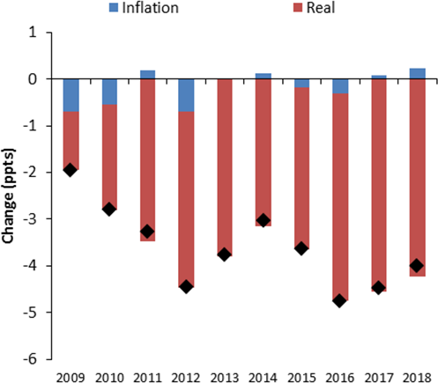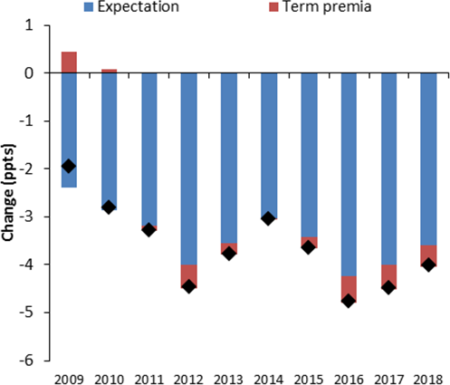

5year rate, 5years forward

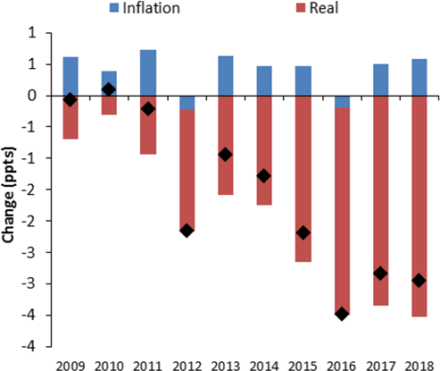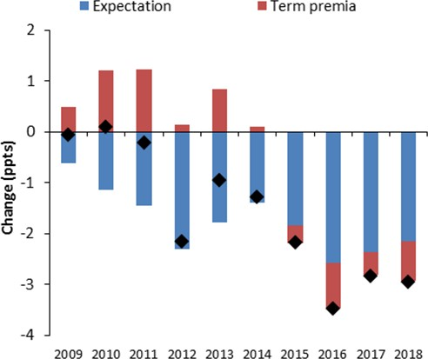

1year rate, 9years forward

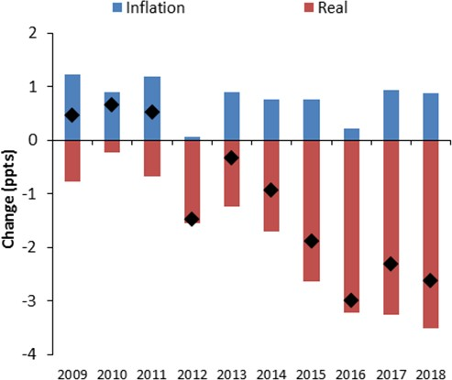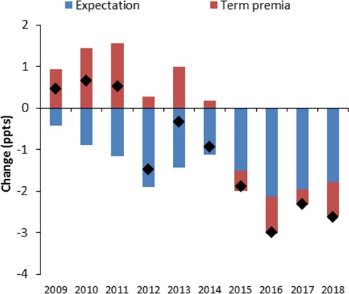

Source: BoE, HMT, Bank calculations, updated models estimates from Guimarães (2012, 2016)

# Figure A2: Evolution of US instantaneous forward rates relative to pre-crisis average

Instantaneous rate, 1-year forward (%)

UST: Instantaneous rate, 2-year forward (%)

UST: Instantaneous rate, 3-year forward (%)

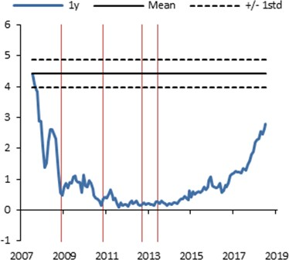

QE1 QE2 QE3 Taper tantrum speech

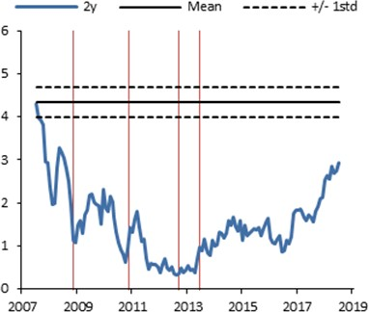

QE1 QE2 QE3 Taper tantrum speech

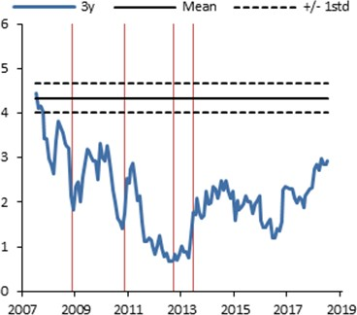

QE1 QE2 QE3 Taper tantrum speech

UST: Instantaneous rate, 11-year forward (%)

UST: Instantaneous rate, 16-year forward (%)

UST: Instantaneous rate, 21-year forward (%)

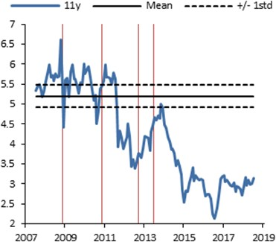

QE1 QE2 QE3 Taper tantrum speech

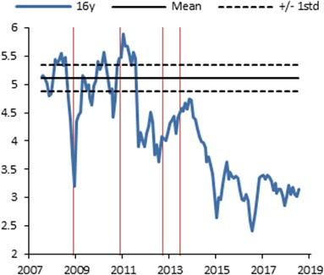

QE1 QE2 QE3 Taper tantrum speech

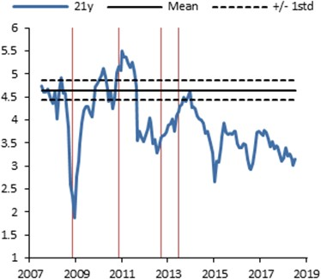

QE1 QE2 QE3 Taper tantrum speech

Note: Mean and standard deviation are calculated for each security between January 2005 and July 2007 Source: BoE calculations

# Figure A3: Range of 10 year spot nominal term premium estimates (different samples and number of factors)

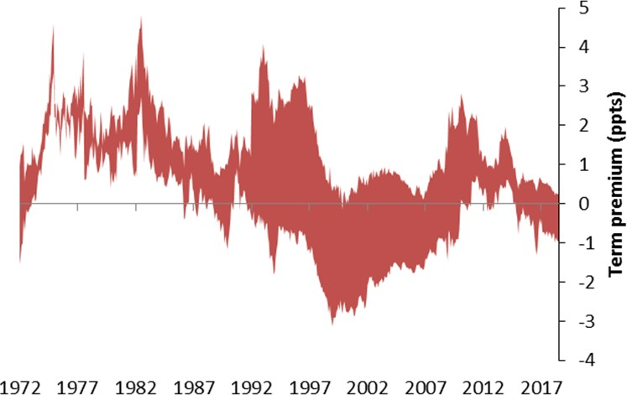

Note: This chart shows the analogous estimates of the term premium as Figure 4, estimated **without survey expectations**.

Sources: BoE, HMT, updated models estimates from Guimarães (2016).

# Figure A4: Reaction of 10 year spot rates for UK QE event study dates

Inflation Report: APF a potential policy instrument

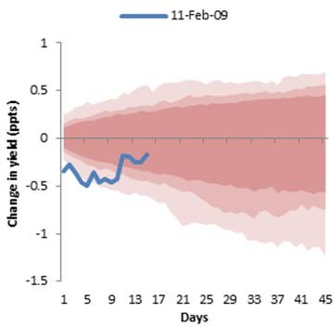

Statement: £175bn QE announced

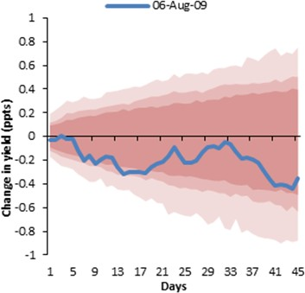

Statement: £325bnQE announced

Statement: £75bn QE announced & 50bps rate cut

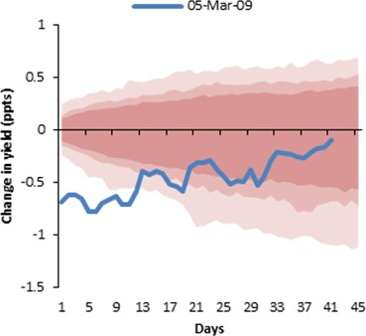

Statement: £200bn QE announced

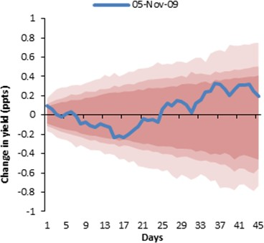

Statement: £375bn QE announced

Statement: £125bn QE announced

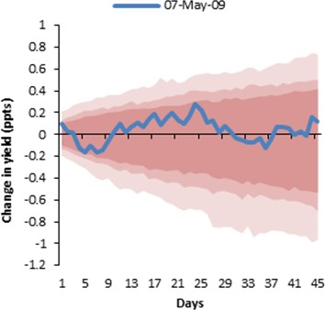

Statement: £275bn QE announced

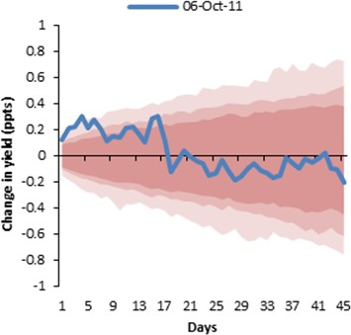

Statement: £435bn QE announced

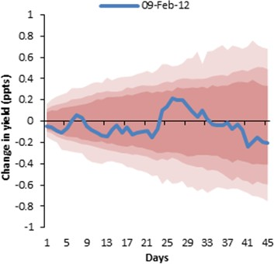 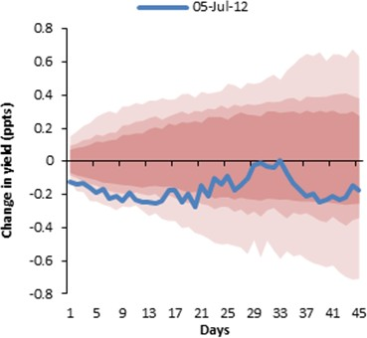 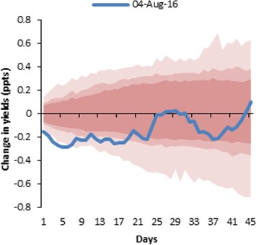

Note: The blue line is the cumulative response of the 10-year spot yield following each QE event. The light, medium and dark red- shaded areas denote the 99%, 95% and 90% confidence internal respectively.

Source: BoE, Bank calculations

# Figure A5: Reaction of 10 year spot rates for US QE1 event study dates

Statement: $100bn GSE, $500bn MBS

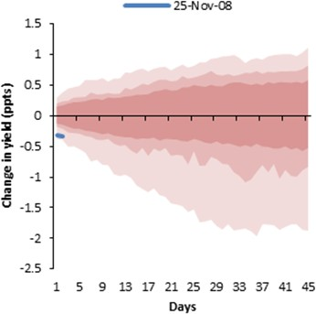

Statement: Stands ready to expand QE and buy Treasuries

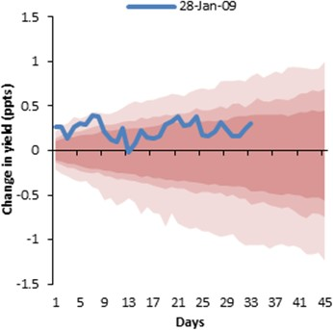

Statement: Took away “up to

$750bn” in MBS

Speech (BB): Could purchase Treasuries in substantial quantities

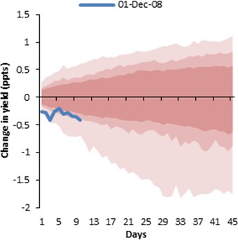

Statement: $100bn GSE, up to

$750bn MBS, up to $300bn Treasuries

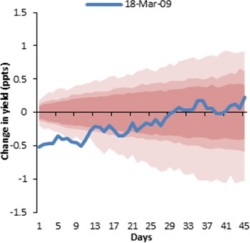

Statement: Swap maturing agency debt into Treasuries

Statement: Committee evaluating the potential benefits of purchasing longer-term Treasuries

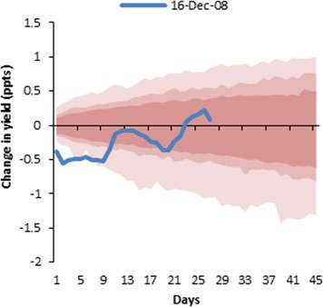

Statement: Took away “up to

$300bn” in Treasuries

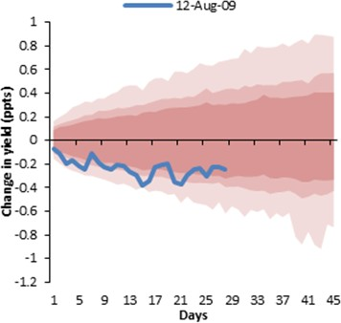

Aggregate US QE1 reaction to 10y spot yields

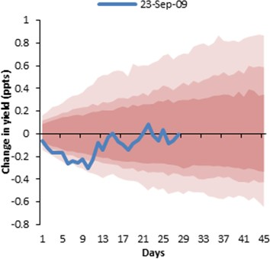 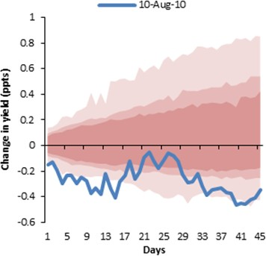 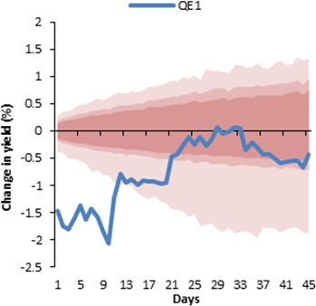

Note: The blue line is the cumulative response of the 10-year spot yield to each QE events. The light, medium and dark red- shaded areas denote the 99%, 95% and 90% confidence internal respectively. The bottom-right chart shows the cumulative response of the 10-year spot yields to all of the US QE1 announcements – analogous to Figure 11 in the main text.

Source: Federal Reserve Board, Bank calculations

# References

**Abel, A. (1999)**, “Risk premia and term premia in general equilibrium”, *Journal of Monetary Economics,* 43 (1999): 3-33.

**Abrahams, M., Adrian, T., Crump, R. and Moench, E. (2016)**, “Decomposing real and nominal yield curves”, *Journal of Monetary Economics,* 84(C): 182-200.

**Alvarez, F., Atkeson, A., Kehoe, P. (2009)**, “Time-Varying Risk, Interest Rates, and Exchange Rates in General Equilibriums”, *The Review of Economic Studies,* 76(3): 851-878.

**Ang, A., Bekaert, G., and Wei, M. (2008)**, "The Term Structure of Real Rates and Expected Inflation,"

*Journal of Finance*, vol. 63, no. 2, pp. 797-849.

**Backus, D., Gregory, A., Zin, S. (1989)**, “Risk premiums in the Term structure: Evidence from Artificial Economies”, *Journal of Monetary Economics,* 24: 971-399

**Baumeister, C. and Benati, L. (2013)**, “Unconventional Monetary Policy and the Great Recession: Estimating the Macroeconomic Effects of a Spread Compression at the Zero Lower Bound”, *International Journal of Central Banking*, 9(2):165-212

**Bekaert, G., Hoerove, M. and Duca, M. (2013)**, “"Risk, Uncertainty and Monetary Policy”, *The Journal of Monetary Economics,* 60(7): 771-788.

**Benati, L. (2008)**, “Investigating Inflation Persistence Across Monetary Regimes”, *The Quarterly Journal of Economics,* 123(3):1005-1060.

**Bernanke, B. (2000),** "Japanese Monetary Policy: A Case of Self-Induced Paralysis?" in R. Mikitani and A.

S. Posen, eds., Japan's Financial Crisis and Its Parallels to U.S. Experience, Washington: Institute for International Economics.

**Bernanke, B. and Kuttner, K. (2005)**, “What Explains the Stock Market's Reaction to Federal Reserve Policy?”, *Journal of Finance,* 60(3), 1221-1257.

**Boneva, L., Cloyne, J., Weale, M. and Wieladek, T. (2016)**, “The effect of unconventional monetary policy on inflation expectations: evidence from firms in the United Kingdom”, *International Journal of Central Banking,* 12(3), 161-195.

**Boyarchenko, N., Haddad, V., Plosser, M. (2017)**, “The Federal Reserve and market confidence”, *Staff Reports from Federal Reserve Bank of New York,* No 773.

**Breeden, D. (1986)**, “Consumption, Production, Inflation and Interest Rates: A Synthesis”, *Journal of Financial Economics*, 16(1): 3-39.

**Broadbent, B. (2018)**, “The history and future of QE”, speech available at: [https://www.bankofengland.co.uk](http://www.bankofengland.co.uk/speech/2018/ben-broadbent-society-of-professional-economists)/s[peech/2018/ben-broad](http://www.bankofengland.co.uk/speech/2018/ben-broadbent-society-of-professional-economists)bent[-soci](http://www.bankofengland.co.uk/speech/2018/ben-broadbent-society-of-professional-economists)e[ty-of-professional-economists](http://www.bankofengland.co.uk/speech/2018/ben-broadbent-society-of-professional-economists)

**Brooks, J, Katz, M. and Lustig, H. (2018)**, “Post-FOMC Announcement Drift in U.S. Bond Markets”,

*Stanford GSB Working Paper*, No. 3268.

**Campbell, J. (1986)**, “Bond and Stock Returns in a Simple Exchange Model”, *Quarterly Journal of Economics,* 101(4):785-804.

**Campbell, J., Shiller, R., and Viceira, L. (2009)**, “Understanding Inflation-Indexed Bond Markets”,

*Brookings Papers on Economic Activity,* Spring: 49-120.

**Carney, M. (2017)**, “Lambda”, speech available at: [https://www.bankofengland.co.uk/speech/2017/lambda](http://www.bankofengland.co.uk/speech/2017/lambda)

**Chapman, D. (1997)**, “The cyclical properties of consumption growth and the real term structure”, *Journal of Monetary Economics,* 39(2): 143-357.

**Chernov, M. and Mueller, P. (2012)**, “The term structure of inflation expectations”, *Journal of Financial Economics,* 106(2): 367-394.

**D’Amico, S. and King, T. (2013)**, “Flow and stock effects of large-scale treasury purchases: Evidence on the importance of local supply”, *Journal of Financial Economics*, 108(2): 425-448.

**D’Amico, S., Kim, D., and Wei, M. (2018)**, "Tips from TIPS: The Informational Content of Treasury Inflation- Protected Security Prices," *Journal of Financial and Quantitative Analysis*, vol. 53, no. 1, pp. 395-436.

**Duffie, D. (2010)**, “Asset Price Dynamics with Slow-Moving Capital”, *Journal of Finance*, 65(4): 1237-1267.

**Evans, M. (1998)**, “Real Rates, Expected Inflation, and Inflation Risk Premia”, *Journal of Finance,* 53(1): 187-218.

**Gagnon, J., Raskin, M., Remache, J. and Sack, B. (2011)**, “The Financial Market Effects of the Federal Reserve's Large-Scale Asset Purchases," *International Journal of Central Banking*, 7(1): 3-43.

**Gorodnichenko, Y. and Weber, M. (2016)**, “Are Sticky Prices Costly? Evidence from the Stock Market”,

*American Economic Review,* 106(1): 165-199.

**Greenlaw, D., Hamilton, J., Harris, E. and West, K. (2018)**, “A Skeptical View of the Impact of the Fed's Balance Sheet”, *NBER Working Paper,* No. 24687

**Greenwood, R. and Vayanos, D. (2010)**, “Price Pressure in the Government Bond Market”, *American Economic Review, P&P*, 585-590.

**Greenwood, R. and Vayanos, D. (2014)**, “Bond Supply and Excess Bond Returns”, *Review of Financial Studies,* 27(3): 663-713.

**Greenwood, R., Hanson, S., and Vayanos, D. (2015)**, “Forward Guidance in the Yield Curve: Short Rates versus Bond Supply”, in Elias Albagli, Diego Saravia, and Michael Woodford, eds.: Monetary Policy Through

Asset Markets: Lessons from Unconventional Measures and Implications for an Integrated World, 2016, Chapter 2, Central Bank of Chile.

**Greenwood, R., Hanson, S., Rudolph, J. and Summers, L. (2016)**, “Managing the US Government’s Debt”, *Brookings Institution Press.*

**Greenwood, R., Hanson, S. and Liao, G. (2018)**, “Asset Price Dynamics in Partially Segmented Markets”,

*Review of Financial Studies,* vol. 31, no.9.

**Guimarães, R. (2012)**, “What accounts for the fall in UK ten-year government bond yields?", *Bank of England Quarterly Bulletin*, 52 (3).

**Guimarães, R. (2016)**, “Fool’s Errand? Robust identification of risk premia and expectations in asset prices”,

*Unpublished Working paper.*

**Haldane, A., Roberts-Sklar, M., Wieladek, T. and Young, C. (2016)**, “QE: the story so far”, *Bank of England Staff Working Paper,* No. 624.

**Hanson, S., and Stein, J. (2015)**, “Monetary Policy and Long-Term Real Rates”, *Journal of Financial Economics,* 115(3): 429-448.

**Hu, X., Pan, J., and Wang, J. (2013)**, “Noise as Information for illiquidity”, *Journal of Finance,* 68: 2223- 2772.

**Inoue, A., and Rossi, B. (2018)**, “The Effects of Conventional and Unconventional Monetary Policy on Exchange Rates”, *NBER Working Paper,* No. 25021.

**Javadi, S., Nejadmalayeri, A. and Krehbiel, T. (2018)**, “Do FOMC Actions Speak Loudly? Evidence from Corporate Bond Credit Spreads”, *Review of Finance,* 22(5): 1877-1909.

**Joyce, M., Lasaosa, A. , Stevens, I. and Tong, M. (2010)**, “The financial market impact of quantitative easing”, *Bank of England Working Paper,* No. 393.

**Joyce, M., Lildholdt, P. and Sorensen, S. (2010)**, “Extracting inflation expectations and inflation risk premia from the term structure: A joint model of the UK nominal and real yield curves”, *Journal of Banking & Finance,* 34(2): 281-294.

**Joyce, M., Tong, M. and Woods, R. (2011)**, “The United Kingdom’s quantitative easing policy: design, operation and impact”, *Bank of England Quarterly Bulletin* 51(3): 200-212.

**Joyce, M. and Tong, M. (2012)**, “QE and the Gilt Market: a Disaggregated Analysis”, *Economic Journal, Royal Economic Society,* 122(564): 348-384.

**Joyce, M., Miles, D., Scott, A. and Vayanos, D. (2012)**, “Quantitative easing and unconventional monetary policy – an introduction”, *The Economic Journal, Royal Economic Society,* November 2012: F271-F288.

**Koijen, R., Koulischer, F., Nguyen, B. and Yogo, M. (2018)**, “Inspecting the Mechanism of Quantitative Easing in the Euro Area”, *Banque de France Working Paper,* No. 601.

**Kim, D. and Wright, J. (2005)**, "An arbitrage-free three-factor term structure model and the recent behavior of long-term yields and distant-horizon forward rates," *Finance and Economics Discussion Series 2005-33, Board of Governors of the Federal Reserve System (U.S.).*

**King, T. (2018)**, “Expectations and Duration at the Effective Lower Bound”, *Federal Reserve Bank of Chicago Working Paper*, No. 2016-21.

**Lucca, D. and Moench, E. (2014)**, “The Pre‐FOMC Announcement Drift”, *Journal of Finance,* 70(1): 329- 371.

**Mamaysky, H. (2018)**, “Time horizon of price responses to Quantitative Easing", *Journal of Banking & Finance,* 90(C): 32-49.

**McLeay, M., Radia, A., Thomas, R. (2014)**, “Money creation in the modern economy?", *Bank of England Quarterly Bulletin 2014 Q1*.

**Meaning, J. and Zhu, F. (2012),** “The impact of Federal Reserve asset purchase programmes: another twist”, *BIS Quarterly Review*, March.

**Nakamura, E. and Steinsson, J. (2018)**, “High-Frequency Identification of Monetary Non-Neutrality: The Information Effect”, *The Quarterly Journal of Economics,* 133(3): 1283-1330.

**Piazzesi, M. and Schneider, M. (2008)**, “Bond Positions, Expectations and the Yield Curve”, Federal Reserve Bank of Atlanta working paper.

**Seppala, J. (2004)**, “The term structure of real interest rates: theory and evidence from UK index-linked bonds”, *Journal of Monetary Economics,* 51(7): 1509-1549.

**Stock, J. and Watson, M. (2007)**, “Why Has U.S. Inflation Become Harder to Forecast?”, *Journal of Money, Credit and Banking,* 39(1): 3-33.

**Swanson, E. (2017)**, “Measuring the effects of Federal Reserve Forward Guidance and Asset Purchases on Financial Markets”, *NBER Working Paper Series,* No. 23311.

**Vayanos, D. and Vila, J-L. (2009)**, “A Preferred-Habitat Model of the Term Structure of Interest Rates?”,

*NBER Working Paper,* No. 15487.

**Vlieghe, G. (2016)**, “Monetary policy expectations and long term interest rates”, speech available at: [https://www.bankofengland.co.uk/](http://www.bankofengland.co.uk/speech/2016/monetary-policy-expectations-and-long-term-interest-rates)spe[ech/2016/monetary-policy-expectations-and-long-term-i](http://www.bankofengland.co.uk/speech/2016/monetary-policy-expectations-and-long-term-interest-rates)n[terest-rates](http://www.bankofengland.co.uk/speech/2016/monetary-policy-expectations-and-long-term-interest-rates)

**Vlieghe, G. (2017)**, “Real interest rates and risk”, speech available at: [https://www.bankofengl](http://www.bankofengland.co.uk/speech/2017/real-interest-rates-and-risk)and.c[o.uk/](http://www.bankofengland.co.uk/speech/2017/real-interest-rates-and-risk)s[peech/2017/real-interest](http://www.bankofengland.co.uk/speech/2017/real-interest-rates-and-risk)-[rates-and-risk](http://www.bankofengland.co.uk/speech/2017/real-interest-rates-and-risk)

**Weale, M. and Wieladek, T. (2016)**, “What are the macroeconomic effects of asset purchases?,” *Journal of Monetary Economics,* 79(2016):81-93.

**Williams, J. (2014)**, “Monetary Policy at the Zero Lower bound: Putting Theory into Practice”, Hutchins Center Working Papers, Brookings.

**Woodford, M. (2003)**, “Interest and Prices: Foundations of a theory of Monetary Policy?”, *Princeton University Press*.

**Woodford, M. (2012)**, “Methods of Policy Accommodation at the Interest-Rate Lower Bound?”, *Proceedings*

*- Economic Policy Symposium - Jackson Hole, Federal Reserve Bank of Kansas City*, pages 185-288.

**Wright, J. (2012)**, “What does monetary policy do to long-term interest rates at the Zero Lower Bound,”

*Economic Journal, Royal Economic Society,* November(2012):F447-F466.